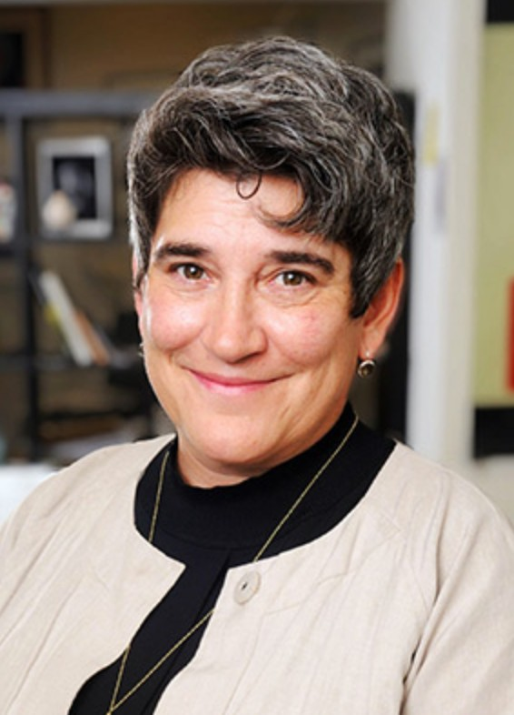

CAP UCLA DIRECTOR ALL AREAS ANYTIME

# CAP UCLA 2018/2019 season

# NADIA SIROTA – WILD UP

# Sat, Jan 12, 2019

**PHOTO PASS** – **House only**

**No backstage**

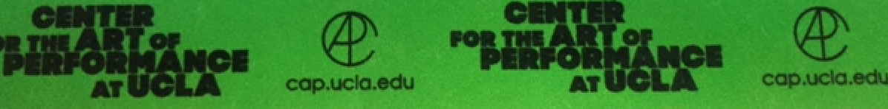

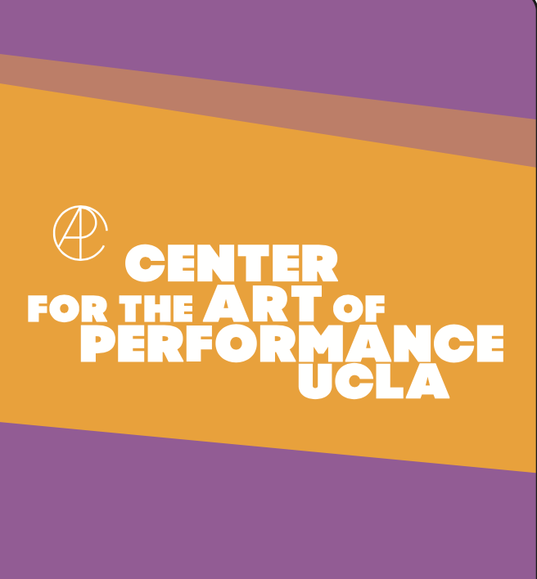 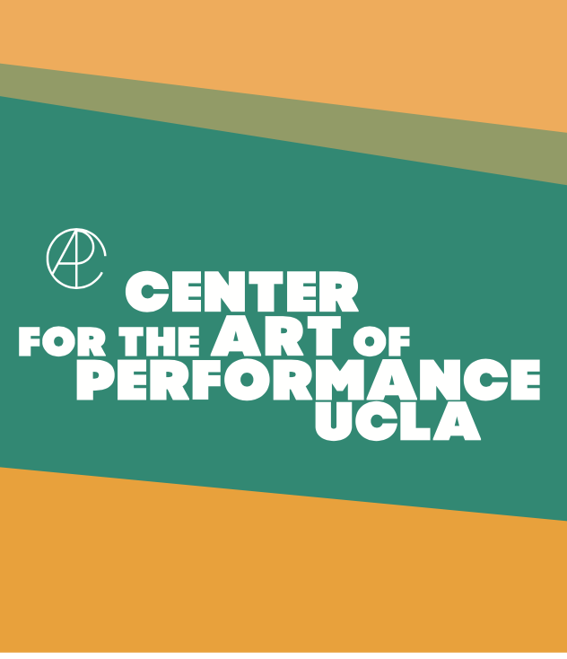

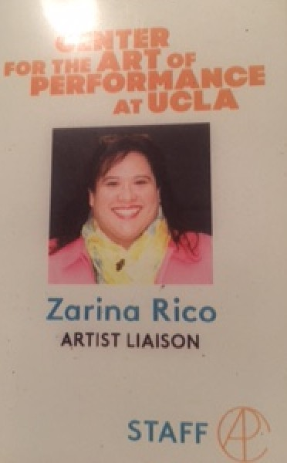

CAP UCLA STAFF LAMINATE

ALL AREAS ANYTIME

Escort anyone with or without pass

ARTIST / PRODUCTION SATIN ALL AREAS ANYTIME

GUESTS – AFTER SHOW BACKSTAGE